**LIBRARY MANAGEMENT SYSTEM**

**Empowering Libraries with Technology – Your Gateway to Smarter Solutions**

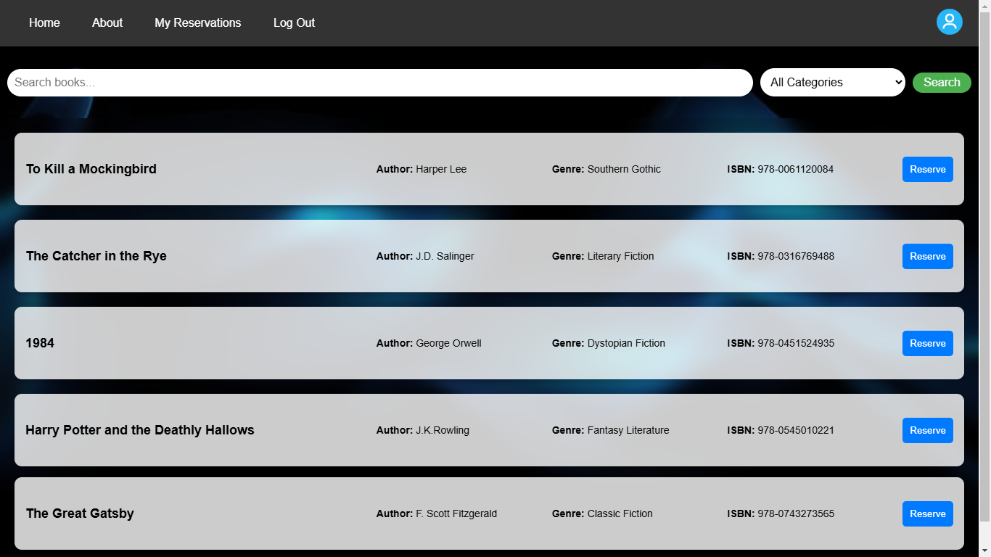

**• Efficiently Manage Books and Reservations • User-Friendly Interface • Real-Time Availability Status • Secure User Management**

**DEVELOPED BY: Jayesh Yadav LIBRARY MANAGEMENT SYSTEM | 2024**